Create - Energy Conversion Machine Project

(Reference Standard: NGSS HS-PS3-3)

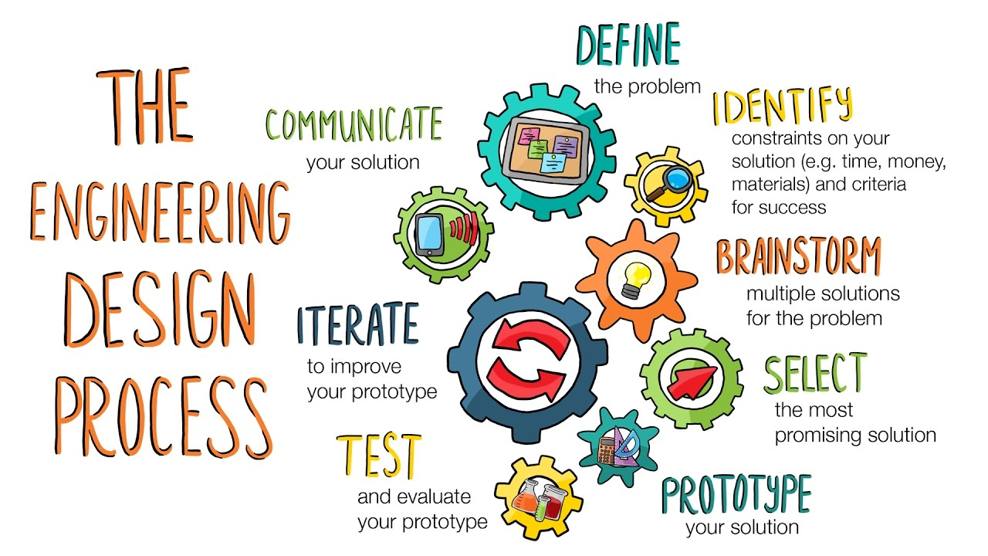Using materials freely available around home and school, you will design, build, and refine a device that works, within the given guidelines, to convert one form of energy into another form of energy. (Examples of devices could include “Rube Goldberg” devices, wind turbines, solar cells, solar heaters (but not a solar oven), and generators.)

Figure . Source: https://cdn.kqed.org/

You will loosely follow the engineering design process to identify your problem and potential solutions and then ***attempt***to solve them in a creative way through energy conversion. Success (and earning points) will not be measured solely on the completed machine and its efficient operation, but more so on the ***effort*** placed in the process. The greatest successes in Science and Engineering are not from the final products created, but in the learning from failures along the way!

“Failure is an option here. If things are not failing, you are not innovating enough.”

Elon Musk

Founder, Tesla and SpaceX

You will follow a set of steps, organized into four (4) parts, to reach your final goal. You will be asked to answer a set of questions in each part related to your research, design, the prototype build and the test of the prototype. In some ways, the answers to the questions are more important than the build itself. Complete and submit each Part to your teacher for approval before continuing to the next Part.

# Part A: Define, Identify, Brainstorm/Select

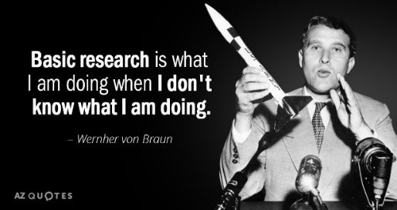In this part you will define the “problem” you are going to “solve.” It doesn’t have to be an actual problem, it can just be a task you would like to make easier, simpler or tackle in a new way – maybe even harder or more complex! Then, within constraints, you will research and brainstorm a solutions for the “problem” and select one. Be creative; challenge yourself!

If you need inspiration, search for “Rube Goldberg machine” or visit this website: <https://pbskids.org/designsquad/parentseducators/resources/index.html?category=forceenergy>

Prepare your answers in a new PPT or Word DOC. You will present this to your teacher after each Part. If you are not creating your own device, but making one from an idea gathered in your research, answer these questions based on that specific device. Otherwise, the questions are to help guide your thinking.

## Watch “[William Kamkwamba: ‘How I Harnessed the Wind’ TED Talk” on EdPuzzle](https://edpuzzle.com/assignments/6082c8f6692e5341562d5698/watch)

## What is the “problem” you would like to solve with an energy conversion device?

William needed electricity to operate the things his family and village needed. Your machine might just “turn off a light” or “turn on the fan” or “melt a chocolate bar and marshmallow” or “charge my phone.” It might just be, “knock over this thing.” Anything can be an option.

## What are the constraints that you have to deal with in picking or designing a solution for your problem? How did the constraints change your decisions or design?

William didn’t have any money and had to identify parts that he found in the dump or around his village and home. Constraints (given):

* Time: You have a set deadline, but if it becomes too difficult, you may ask for an extension IF you are making good progress
* Recycled materials only: You are encouraged to use only what you already have laying around your house, in the recycling or trash, or available at school. Be creative!

List other constraints you may have. Consider space, availability of the energy source you are using for input (e.g. the Sun is only visible during the daytime or the wind only blows some of the time.) Think about all the things that may limit your energy source, materials, or design.

## Do some research and/or brainstorm solutions. What device will you build and how will your device solve your problem?

William found a book in the library about windmills producing electricity in other parts of the world and said to himself, “I can do that! It will take the wind I have and give me electricity.”

# Part B: Design

## Design a prototype of your energy conversion machine

William designed a machine that used trees as poles for a tower, a radiator fan from a car, a bicycle frame, a wheel, pulleys, automotive fan belts, and a dynamo from a bicycle light as his generator. To move the electricity from the top of the tower to the house he used copper wire.

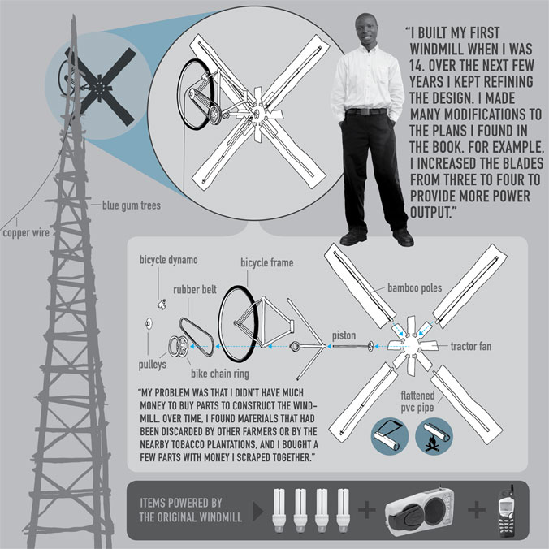Draw your design on the computer or on paper, make sure to include labels for each item used and the material from which the item is made.

Figure . Source: https://inspiringideasblog.wordpress.com/2013/04/20/moving-windmills-the-story-of-william-kamkwamba/

# 5 Best Steve Jobs QuotesPart C: Communicate Your Design

## Identify what scientific principles provide the basis for the energy conversion design

In the library book, William saw how the wind would blow against angled blades of a fan (which was usually used to *create* wind, not harness it) to make it spin. He also knew that the dynamo from the bike light took mechanical energy from the spinning wheel to spin the dynamo which spun a generator to create electricity with magnets and copper wire. Applying these two scientific principles together he began to form his energy conversion machine design.

Explain how each part of your machine works, using scientific language and vocabulary. It may be as simple as “gravity pulls the weight, hanging on a spring, toward the Earth and tension pulls on the spring to create potential energy.”

## Identify the forms of energy that will be converted from one form to another in the designed system

William converted wind energy into mechanical energy using a windmill. He then converted mechanical energy into electrical energy to operate his radio, charge mobile phones and, eventually, pump water. For example, your whole machine may use solar from the sun to heat a dark surface or reflect onto something, converting it to thermal energy or it may use gravity (potential energy) to pull or push something creating kinetic energy. The options are pretty varied.

## Identify losses of energy by the designed system to the surrounding environment

For William, the machine was not 100% efficient, when the wind blew, not all the air pushed the fan; some spilled around it. As well, the wheel, fan belts and dynamo created heat energy from friction which was lost to the air and was not used to turn the dynamo. Where in your machine design is it losing some energy? No machine ever built is 100% efficient!

## Describe the scientific rationale for choices of materials and structure of the device, including how student-generated evidence influenced the design

The library book showed windmills made on steel towers and aluminum fan blades, but William only had wood to build his tower where he lived, so his design changed from the original design. What choices did you have to make with materials and design plans? Did you realize that you had to change the design because it may not work as you originally planned it? Did the constraints prevent you from using any particular idea or material? Did you not have the original materials you wanted available to you?

## Describe how the device is an example of how the application of scientific knowledge and engineering design can increase benefits for modern civilization while decreasing costs and risk

How will this device make life better or more efficient? Will it save money, time, or in some other way make things more fun or convenient? Will it cure boredom? For William, his village was in a drought (had no rain) and didn’t have a reliable energy source to power the things they needed (mobile phones) or wanted (radio to listen to sports). His machine gave them the power they needed to water their crops, whether it rained or not! They now had access to well water when the rains didn’t fall.

## Describe and quantify (when appropriate) priorities placed on criteria and constraints for the design of the device, along with the tradeoffs in the design solution.

Did you have to make any trade-offs in your design? Did you sacrifice how hot it would make something because you didn’t have enough tinfoil or you made it smaller because you didn’t have enough materials?

# Part D: Prototype, Test, and Iterate

## Build the device according to the plan

Based on the plans you drew up, build the device. It should be built as close as possible to the original design. If you make modification from the original design, keep notes so that you can explain those changes later.

## Test the device according to the plan

In class, on Zoom, in a video recording, or time-series photos, test the machine, keeping good notes about how well it worked. (Evidence of the build and testing is required for credit.)

## Systematically and quantitatively evaluate the performance of the device against the design criteria, restraints and constraints

You stated earlier how the device was planned to work, citing the science and energy conversions that would work within the system. How did it actually work? Did all the parts work the way you thought that they would? What worked well? What didn’t work well (or failed completely?) What numbers or data do you have to prove that it worked or didn’t work as designed? (E.g. did it lift the item you had intended, or was it too heavy, but the device did successfully lift something lighter?)

## Identify how test results can be used to improve the device performance by increasing the efficiency of energy conversion, keeping in mind the criteria and constraints, and noting any modifications in tradeoffs.

Did you have to revise your design and rebuild the device to work correctly? How can it be redesigned to improve how it works or solve any individual failure points or trouble spots in the machine? Can you add design features to make it more pleasing to look at, quieter, take up less space, etc.?

## Describe how test results demonstrated increased efficiency of energy conversion, while remaining inside the bounds of the criteria and constraints, and noting any modifications in tradeoffs.

If the device worked as designed, how well did it convert energy? Did it actually improve life in some way? If you redesigned and rebuilt the machine, what improvements in efficiency or effectiveness were made?

If the device did not work, how did it fail? What did it not do? What changes did you or would you make to fix problems, improve efficiency, improve effectiveness, or make it generally more attractive?